TEACHER:MWALE CHIPO

DESIGN AND TECHNOLOGY DEPARTMENT

LESSON PLAN

SUBJECT: DESIGN AND TECHNOLOGY CLASS:…… … DATE:……/……./20…. DURATION:………….
BOYS:…………………… GIRLS ………………………………………. TOTAL OF PUPILS… TOPIC: FORM WORK SUBTOPIC: FORM WORK FOR SLAB LEARNING OUTCOMES LSBAT
- Define form work
- Identify three types of frame work
- Identify the recommended timber to use in construction (shuttering)
- Erect form work for concrete walls

RATIONALE
Knowledge: Work plan, Material selection, Form work positions, Construct formwork
Skills: Interpretation of, work plans, Constructing, form work
Values:
- Awareness of assembling parts of a hipped and valley roof and Observation of safety precautions when constructing roofs and Appreciation of beauty when finishing construction work
TEACHING AIDS
PART | LESSON CONTENT | METHODOLO GY | LEARNER ACTIVITY
introduction | - Recap on the previous lesson | Questions and answers | Provide answers
Development | FORM WORK  - Form work is the term given to either temporary or permanent moulds into which concrete or similar materials are poured.  - Shuttering refer to where planks are fixed together to hold concrete in order to construct a lintel or pillar.  Types of frame work  - Concrete slab frame work  - Construction form work  - Concrete mix design  RECOMMENDED TIMBER TO USE IN FORMWORK( SHUTTERING)  - Well-seasoned (dried) to avoid complications such as cracking  - Light weight  - Easy to nail without cracking  - Free from defects (warping) because these will transfer to the concrete  - Smooth on both sides to give the concrete a clean finish.  REQUIRED SIZES FOR SLAB CONSTRUCTION | Questions And Answers  Demonstration  V/E | Taking note of important points  Provide answers
Application | CLASS EXERCISE  - Clearly indicate the advantages and disadvantages of using untreated timber for shuttering | Questions And Answers | Provide answers
Conclusion | - Recap on the main steps and points | V/E
TEACHER EVALUATION
Description | Size (mm)
Beam columns for sides and bottom | 25mm-40mm thick
Joints or edge | 50 x 70 to 50 x 150 mm
Posts for structure support | 75 x 100 to 100 x 100
Plywood | Standard thickness

TEACHER:MWALE CHIPO

DESIGN AND TECHNOLOGY DEPARTMENT
LESSON PLAN

SUBJECT: DESIGN AND TECHNOLOGY CLASS:…… … DATE:……/……./20…. DURATION:………….
BOYS:…………………… GIRLS ………………………………………. TOTAL OF PUPILS… TOPIC: FORM WORK SUBTOPIC: ROOF CONSTRUCTION LEARNING OUTCOMES LSBAT
- Identify parts of a hip roof
- Interpret plans for a hipped roof
- Construct a hipped and valleys roof

RATIONALE
Knowledge: Roof terminologies/ Parts of a hipped and valley roof/
Skills: Identification of parts of a hipped roof /Interpretation of roof drawings/ Application of principles
Values: Observation of safety precautions when constructing roofs and

TEACHING AIDS
PART | LESSON CONTENT | METHODOL OGY | LEARNER ACTIVITY
introduction | - Recap on the previous lesson | Questions and answers | Provide answers
Development | ROOF CONSTRUCTION  HIPPED ROOF  - A hipped roof is a type of roof that considered rafters covered in all the corners leaving no naked wall exposed to external weather conditions  SAFETY WHEN WORKING ON ROOFS  - Erecting scaffolding up to lower level of the roof to save anyone who slips down a roof slope  - Pick a clear, calm, cool time of day to work on roofs. Wet roofs are slippery. Wind also poses a danger, and excessive heat softens the shingles, making them vulnerable to damage.  - Wear shoes with a soft rubber sole for extra traction.  - Keep the bottom of your shoes free of mud and dirt, and the roof swept clear of dirt and debris  - Always watch out for fall hazards when working at heights.  PARTS OF A HIPPED ROOF  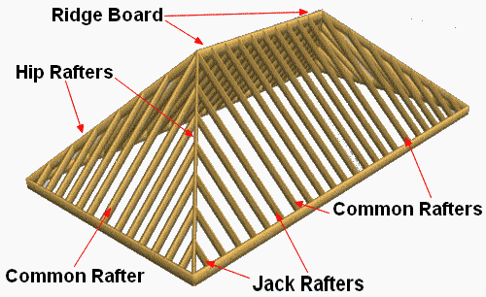  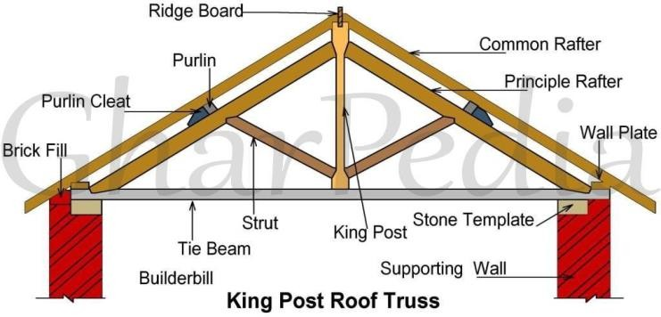
Application | CLASS EXERCISE  Draw and label the parts of a truss | Questions And Answers | Provide answers
Conclusion | - Recap on the main steps and points | V/E
LESSON EVALUATION

